
Sukkur Institute of Business Administration University
Department of Computer Science
BS – I (CS/SE) Fall 2024
Programming Fundamentals
Lab # 05: To become familiar with the basics of string datatype, if-else statement, nested if-else statement and switch statement

Lab Report Rubrics  (Add the points in each column, then add across the bottom row to find the total score) |  |  |  |  | Total Marks
S.No | Criterion | 0.5 | 0.25 | 0.125
1 | Accuracy | - Desired output | - Minor mistakes | - Critical mistakes
2 | Timing | - Submitted within the given time | - 1 day late | - More than 1 day late
Submission Profile
Name: Submission date (dd/mm/yy):
Enrollment ID: Receiving authority name and signature:
Comments: __________________________________________________________________________
Instructor Signature

Note: Submit this lab hand-out in the next lab with attached solved activities and exercises

Objectives
After performing this lab, students will be able to
- Understand the basics of string data type and use it in programs
- Understand the if-else statement and create programs using it
- Understand nested if (or if-else) statement
- Understand and use switch-case statement

Basics of string data type
The string is a class, different from the primitive data types discussed so far. We will discuss it in detail in the later part of this course.
Because a char variable can store only one character in its memory location, another data type is needed for a variable able to hold an entire string (collection of character/more than 1 characters). Although C++ does not have a built-in data type able to do this, standard C++ provides something called the string class that allows the programmer to create a string type variable.
The first step in using the string class is to #include the string header file. That can be done as shown below:
You have to use double quotes around the text to store it into a string variable. The following code snippet shows how to create a variable of type string:

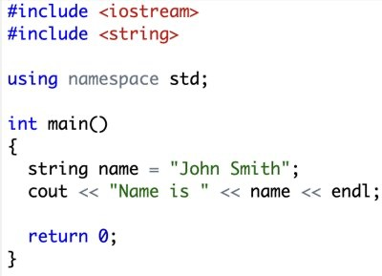

Output:

Getting Input into a string variable
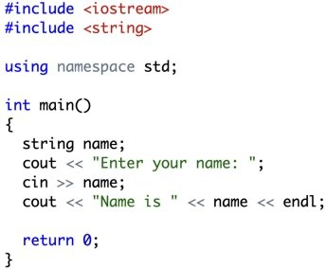

Output:
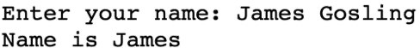
Here, only the first word “James” is assigned to the variable. The text after the space after the first word is ignored. To get the entire line of text, we should use a built-in function getline ( ) as shown below
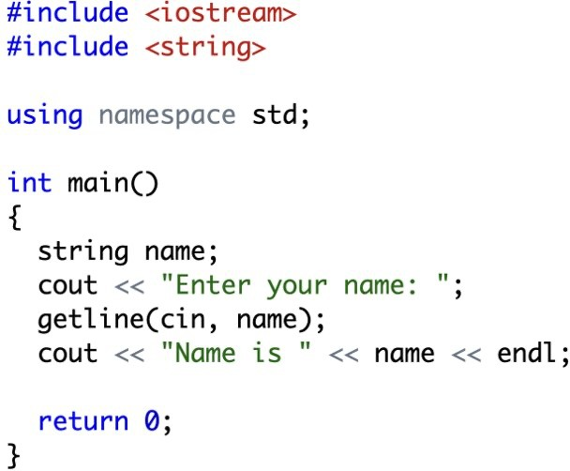

Output:
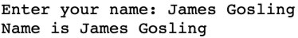

Output with another value (consisting of three words):
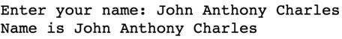

Control structures

In C++, control structures are used to dictate the flow of a program's execution. Control structures allow you to make decisions or repeat actions. The main control structures in C++ include:

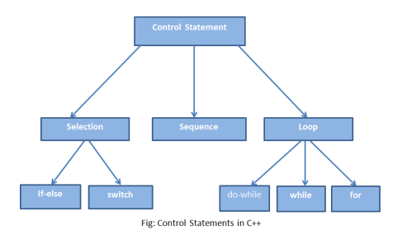

Conditional Statements

A conditional control structure is a fundamental concept in computer programming that allows you to control the flow of a program based on specified conditions or criteria. It enables you to make decisions in your code, executing different sets of instructions depending on whether a condition or set of conditions is met.
Branch statements let program choose between two alternatives. For example, if the student has obtained 60 or above marks, then he/she can be declared as pass. These instructions are sometimes also called as selection statements. The selection statements allow to choose the set of instructions for execution depending upon a controlling expression's truth value (whether it is true or false). C++ provides following two types of selection statements:
- if (or if-else) statements
- switch statement

The if statement
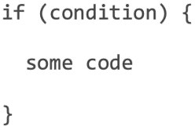
In C++, if statement is used to perform branching (or sometimes also called as jumping because the code is not executed sequentially. Instead, the execution depends upon a condition). Its general syntax is:
If the condition evaluates to a non-zero value (or true), then the statements within if are executed. Otherwise, the statements are skipped, and the program continues on.

This can be illustrated by the following figure:

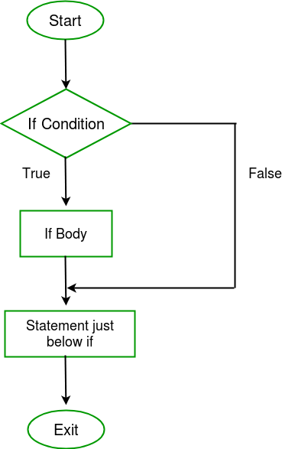

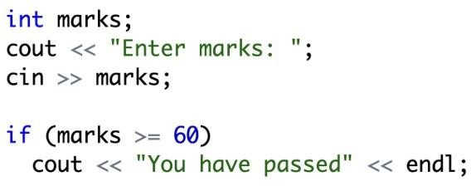
Example:
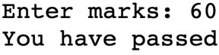
Output 1:
Entered marks are equal to 60, hence the output is “You have passed”

Output 2:
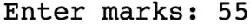
Now, the entered marks are less than 60. So, the condition of if statement (marks >= 60) is not true. Therefore, the code inside the if block does not run (does not print anything).
If you have only one line of code that should be executed when the condition true, then you can write the code as shown above (i.e., no need to write the curly brackets). However, it is a good practice (and a recommended way) to use the brackets, as shown below:
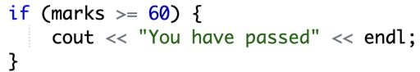
The code inside the brackets is called the body of if statement.
If multiple lines of codes need to be executed inside the if statement, then you must write those multiple lines inside the curly brackets. Otherwise, only the first line after the if statement will be considered its part. For example,
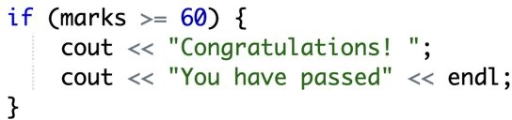
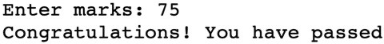
Output:
Here, the code works as expected. Nevertheless, if we do not use the curly brackets, like
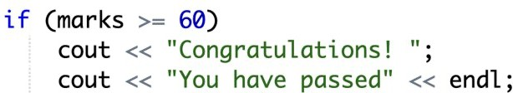

Output 1:
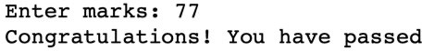
Even though now the output looks correct. But it is not. Only the first line (printing “Congratulations!”) is part of the if statement. The second line (saying “You have passed”) is the normal line and will be executed regardless of whether the condition is true or false.

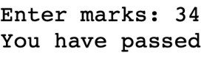
Output 2:
Even though now when marks are less than 60, it says “You have passed” because that line does not depend on the condition (because it is NOT the part of if statement. Only the line saying “Congratulations!” is skipped because that was considered to be the part of if statement. Hence, it is recommended to use curly brackets (even if there is only one line.)

The if-else statement
If the situation is such that there are two options/possibilities. If the condition becomes true, then one statement should execute. On the other hand, if the condition becomes false, then the second statement should execute. In such case, if-else statement should be used. Its general syntax is:
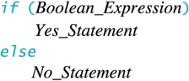
Here, any of these two parts will run. If the condition is true, then only the body of if statement will run (and else will NOT run). Otherwise, if the condition is false, then only the body of else statement will run (because the body of if statement will be skipped). See the following figure:
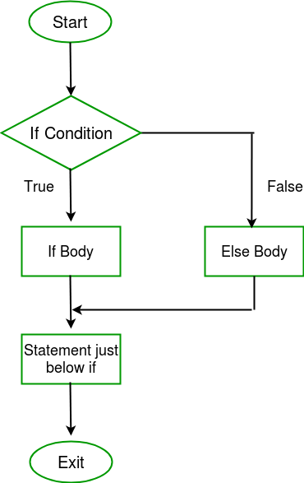
For example,
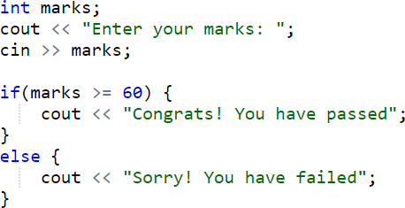

Output 1:
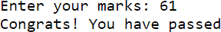
Output 2:
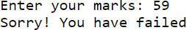

Nested if statement

Nested if means you can put an if statement (including any else if – else) inside another if or

else if statement(s). Its general syntax is:

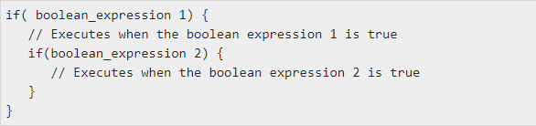
You can use else if – else in the similar way as if is nested in the above-given syntax.

Example:

// C++ program to find if an integer is even or odd or neither (0)

// using nested if statements

#include <iostream>

using namespace std;

int main() {

int num;

cout << "Enter an integer: ";

cin >> num;

// outer if condition

if (num != 0) {

// inner if condition

if ((num % 2) == 0) {

cout << "The number is even." << endl;}

// inner else condition

else {

cout << "The number is odd." << endl;}}

// outer else condition

else {

cout << "The number is 0 and it is neither even nor odd." << endl;}

cout << "This line is always printed." << endl;}

Output: 1

Enter an integer: 34 The number is even.

This line is always printed.

Output: 2

Enter an integer: 35 The number is odd.

This line is always printed.

Output: 3

Enter an integer: 0

The number is 0 and it is neither even nor odd. This line is always printed.

In the above example,

We take an integer as an input from the user and store it in the variable num.

We then use an if...else statement to check whether num is not equal to 0.

If true, then the inner if...else statement is executed.

If false, the code inside the outer else condition is executed, which prints "The number is 0 and neither even nor odd."

The inner if...else statement checks whether the input number is divisible by 2.

If true, then we print a statement saying that the number is even.

If false, we print that the number is odd.

Notice that 0 is also divisible by 2, but it is actually not an even number. This is why we first make sure that the input number is not 0 in the outer if condition.

The switch statement

A switch statement allows a variable to be tested for equality against a list of values. Each value is called a case, and the variable being switched on is checked for each case. Its general syntax is:

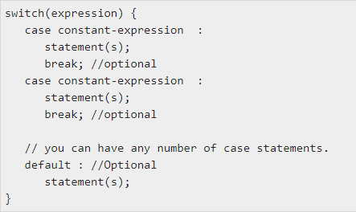

The following rules apply to a switch statement

The expression used in a switch statement must have an integral type (int, char etc.).

You can have any number of case statements within a switch. Each case is followed by the value to be compared to and a colon “:”.

The constant-expression for a case must be the same data type as the variable in the switch.

When the variable being switched on is equal to a case, the statements following that case will execute until a break statement is reached.

When a break statement is reached, the switch terminates, and the flow of control jumps to the next line following the switch statement.

Not every case needs to contain a break. If no break appears, the flow of control will fall through to subsequent cases until a break is reached.

A switch statement can have an optional default case, which must appear at the end of the switch. The default case can be used for performing a task when none of the cases is true (it is similar to else statement in if-else). No break is needed in the default case.

Example:

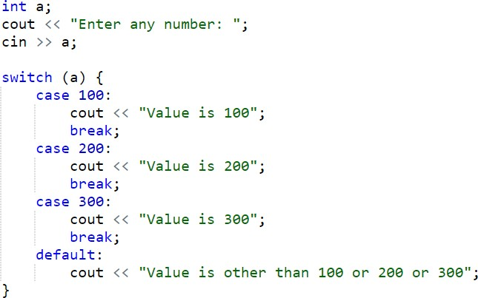

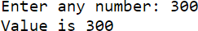
Output 1:

Output 2:
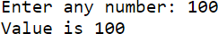

Output 3:

The use of break is important. Otherwise, when one case becomes true, all the subsequent case (cases after that case) will also be executed regardless of whether their condition is true or false.

Example 2 (where break statement is NOT used):

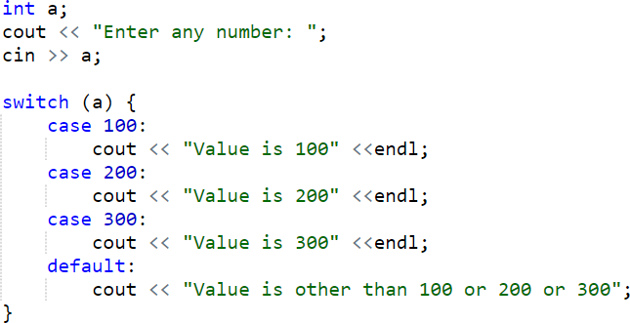

Output 1:

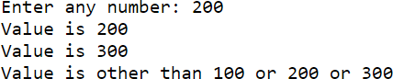

Output 2:

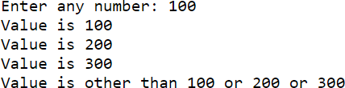

Here, you can see that when a particular case becomes true, then all the cases after it (and the default case) execute even if their condition is not true. Therefore, it is necessary to use the break statement to avoid such behavior of programs.

exit ( ) in C++:
The exit function, declared in <stdlib. h>, terminates a C++ program. The value supplied as an argument to exit is returned to the operating system as the program's return code or exit code. By convention, a return code of zero means that the program completed.

Example (without exit() function)
#include <iostream>
using namespace std;
int main() {
int choice;
cout << "Enter a choice (1 or 2): ";
cin >> choice;

switch (choice) {
case 1:
cout << "You selected option 1." << endl;
// Exit the switch block, but continue with the rest of the program.
break;
case 2:
cout << "You selected option 2." << endl;
// Exit the switch block, but continue with the rest of the program.
break;
default:
cout << "Invalid choice." << endl;
// Exit the switch block, but continue with the rest of the program.
break;
}
// Rest of the program continues here.
cout << "Program continues after the switch." << endl;
return 0;}
Example (with exit( ) function):
#include <iostream>
#include <cstdlib> // Include the header for exit()

using namespace std;

int main() {
int choice;
cout << "Enter a choice (1, 2, or 3): ";
cin >> choice;

switch (choice) {
case 1:
cout << "You selected option 1." << endl;
break;
case 2:
cout << "You selected option 2." << endl;
break;
case 3:
cout << "Exiting program..." << endl;
exit(0); // Exit the entire program with a status code of 0
break; // This is technically unreachable code due to exit() above
default:
cout << "Invalid choice." << endl;
break;
}

// Rest of the program continues here.
cout << "Program continues after the switch." << endl;

return 0;
}

Exercise

If/Else and Nested If/else Tasks:

- Write a program that should ask the user to input his/her marks of one subject (out of 100). Then, it should tell the CGPA according to his/her marks. Details/rules of the CGPA are given below:
Marks | CGPA
93 (or above) | 4.00
87 to 92 | 3.67
82 to 86 | 3.33
77 to 81 | 3.00
72 to 76 | 2.67
68 to 71 | 2.30
64 to 67 | 2.00
60 to 63 | 1.67
0 to 59 | 0.00

- Write the program where you ask the user to input his/her marks for five subjects and calculated his/her obtained marks and percentage. So, after calculating the percentage, you should also tell his/her grade according to the rules given below:
Percentage | Grade
90 (or more) | A1
80 to 89 | A
70 to 79 | B
60 to 69 | C
Less than 60 | F

- Write a program that prompts the user to enter a vehicle's speed and the speed limit. Use the conditional statement to determine and display whether the vehicle is within the speed limit or if it's speeding. If it's speeding, calculate and display the fine amount as follows: $10 for every 5 mph (mile per hour) over the limit.

- Write a program that prompts the user to input a number. The program should then output the number and a message saying whether the number is positive, negative, or zero.
- Write a program that asks the use to input any month number in integer (like 1, 2, …, 12) and display the respective month name in the word (like January, February, …, December).
- Write a C++ program that asks the user to input two numbers and tell
    - if the first number is greater than the second number
    - if the second number is greater than the first one
    - or both numbers are equal

- Write a C++ program that asks a user to input three numbers and tell which one is the largest of them. See the sample outputs below:
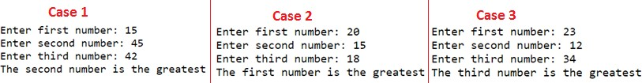
- Write a C++ program that asks a user to input two numbers and then the operator (+ or – or * or / etc.) to show which operation is to be performed on those two numbers. Like shown below:
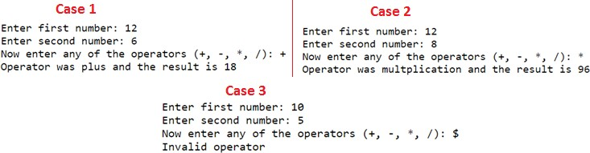
- Create a program that prompts the user to enter the temperature in Celsius. Determine whether it's a "hot day," a "moderate day," or a "cold day" based on the following conditions:
    - Hot: Temperature is above 30°C.
    - Moderate: Temperature is between 20°C (inclusive) and 30°C (exclusive).
    - Cold: Temperature is 20°C or below.

- Write a program that asks the frequency of color and print the corresponding color as given in the table below:
Frequency | Color
Less than 508 | Red
508-525 | Yellow
526-605 | Green
606-668 | Blue
More than 668 | Violet
Switch Statement Tasks:

  - Write a program that asks the user to input two numbers and an operator (+, -,*, or /), and then perform the operation (addition, subtraction, multiplication, or division) on the two entered numbers according to the operator input by the user. If the entered operator is not from these four operators, the program should display an error message saying that the entered operator is invalid.

  - Write a program that should ask the user to input a month number (from 1 to 12) and then display the respective month name in words (like January for 1, February for 2 and so on). If the user inputs value other than numbers from 1 to 12, the program should display a message saying that it is an invalid month number.

  - Write a program that ask the user to input a month (from 1 to 12) and then display which season currently it is. The season should be displayed as per the following rules
      - If the month number is 12 or 1 or 2, then it is the Winter season
      - If the month number is 3 or 4, then it is the Spring season
      - If the month number is 5 or 6 or 7 or 8 or 9, then it is the summer season
      - If the month number is 10 or 11, then it is the Autumn season

  - Write a program that should ask the user to input an alphabet character (small or capital) and tell if it is a vowel or a consonant.

  - Write a program that should ask the user to input an integer number and print whether it is even or odd.

